**1. Download vechile sales data -> https://github.com/shashank-mishra219/Hive-Class/blob/main/sales_order_data.csv**

hadoop fs -mkdir /user/itv002776/warehouse/temp_files

**2. Store raw data into hdfs location**

hadoop fs -put 'sales_order_data.csv' /user/itv002776/warehouse/temp_files

**3. Create a internal hive table "sales_order_csv" which will store csv data sales_order_csv .. make sure to skip header row while creating table**

create table sales_order_csv

> (

> ORDERNUMBER int,

> QUANTITYORDERED int,

> PRICEEACH float,

> ORDERLINENUMBER int,

> SALES float,

> STATUS string,

> QTR_ID int,

> MONTH_ID int,

> YEAR_ID int,

> PRODUCTLINE string,

> MSRP int,

> PRODUCTCODE string,

> PHONE string,

> CITY string,

> STATE string,

> POSTALCODE string,

> COUNTRY string,

> TERRITORY string,

> CONTACTLASTNAME string,

> CONTACTFIRSTNAME string,

> DEALSIZE string

> )

> row format delimited

> fields terminated by ','

> tblproperties("skip.header.line.count"="1")

> ;

**4. Load data from hdfs path into "sales_order_csv"**

load data inpath '/user/itv002776/warehouse/temp_files/sales_order_data.csv' into table sales_order_csv;

**5. Create an internal hive table which will store data in ORC format "sales_order_orc"**

create table sales_order_orc

> (

> ORDERNUMBER int,

> QUANTITYORDERED int,

> PRICEEACH float,

> ORDERLINENUMBER int,

> SALES float,

> STATUS string,

> QTR_ID int,

> MONTH_ID int,

> YEAR_ID int,

> PRODUCTLINE string,

> MSRP int,

> PRODUCTCODE string,

> PHONE string,

> CITY string,

> STATE string,

> POSTALCODE string,

> COUNTRY string,

> TERRITORY string,

> CONTACTLASTNAME string,

> CONTACTFIRSTNAME string,

> DEALSIZE string

> )

> stored as orc;

**6. Load data from "sales_order_csv" into "sales_order_orc"**

from sales_order_csv insert overwrite table sales_order_orc select *;

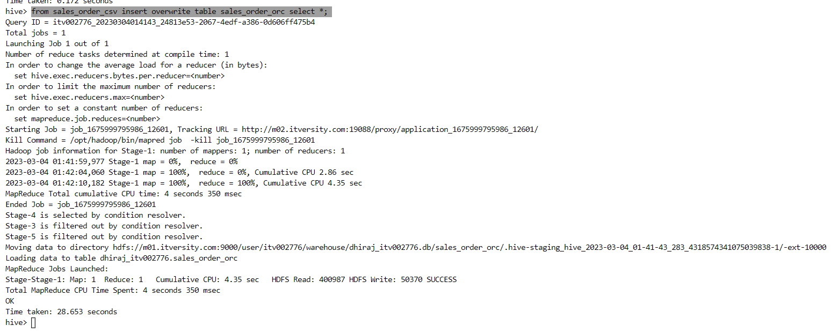

**Perform below menioned queries on "sales_order_orc" table :**

1. **Calculatye total sales per year**

select YEAR_ID,sum(SALES) from sales_order_orc group by YEAR_ID;

1. Find a product for which maximum orders were placed

select PRODUCTCODE,Count(*) as count1 from sales_order_orc group by PRODUCTCODE order by count1 desc limit 1;

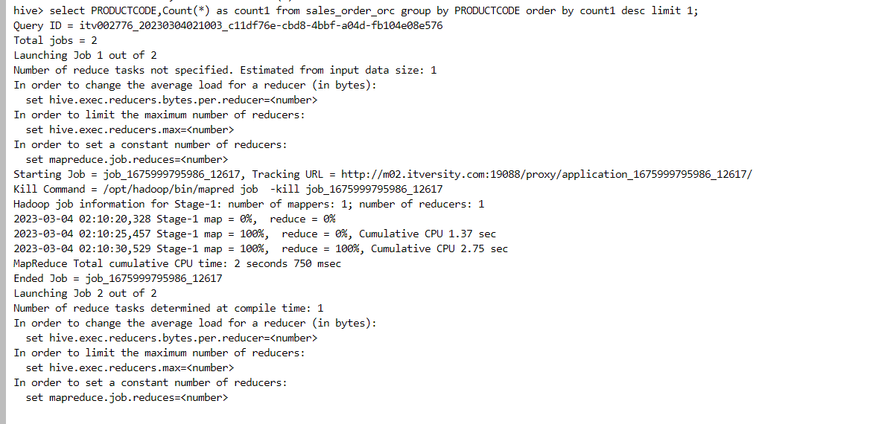

1. Calculate the total sales for each quarter

select QTR_ID,sum(SALES) from sales_order_orc group by QTR_ID;

1. In which quarter sales was minimum

select QTR_ID,sum(SALES) as salesamount from sales_order_orc group by QTR_ID order by salesamount desc limit 1;

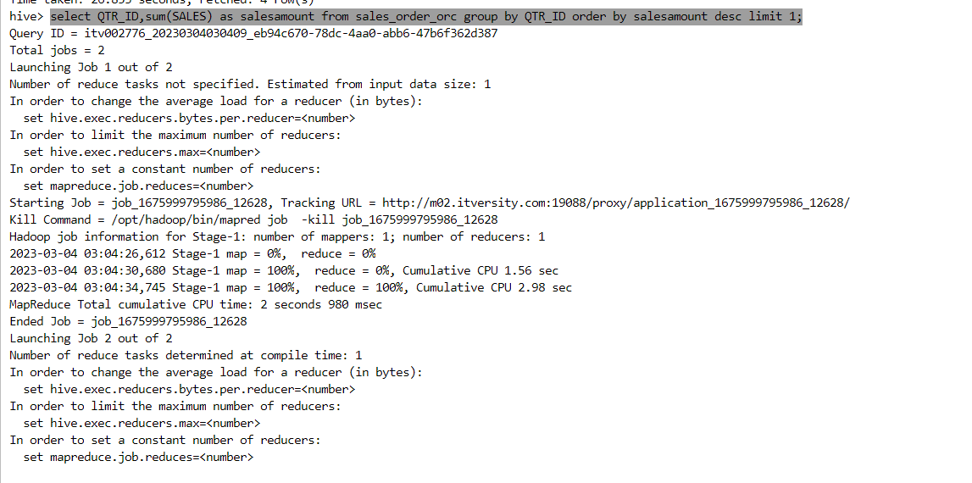

1. In which country sales was maximum and in which country sales was minimum

MAX: select city,sum(sales) as salesamount from sales_order_orc group by city order by salesamount desc limit 1;

MIN: select city,sum(sales) as salesamount from sales_order_orc group by city order by salesamount limit 1;

f. Calculate quartelry sales for each city.

select city,QTR_ID,sum(SALES) as salesamount from sales_order_orc group by CITY,QTR_ID order by city;

h. Find a month for each year in which maximum number of quantities were sold

select YEAR_ID,max(itemsold) from (select YEAR_ID,MONTH_ID,count(*) as itemsold from sales_order_orc group by YEAR_ID,MONTH_ID) temptable group by YEAR_ID;

